About Us
Whyalla Garden Centre is the result of the Higgins family evolving their business interests over the past 60+ years, to suit the times and places in which they have lived.
It was on November 1, 1960 when Leonard Tucker, a dry cleaner in Whyalla, and his son in law Vin Higgins, a farmer from Laura, bought a small dry-cleaning factory at 227 McBryde Terrace.
Named James Dry Cleaners, the venture ran to plan convincing Vin to sell his farm and bring his wife Betty and two young children, Bruce and Leanne, to Whyalla to live in 1963. Just next door at 225 McBryde Terrace was Whyalla Dry Cleaners, so it made good sense to buy out this business so James Dry Cleaners expanded in 1964.
With the opening of Westland’s Shopping Centre in March 1968 also came the unveiling of James dry Cleaning's two-hour cleaning shop at the new complex.
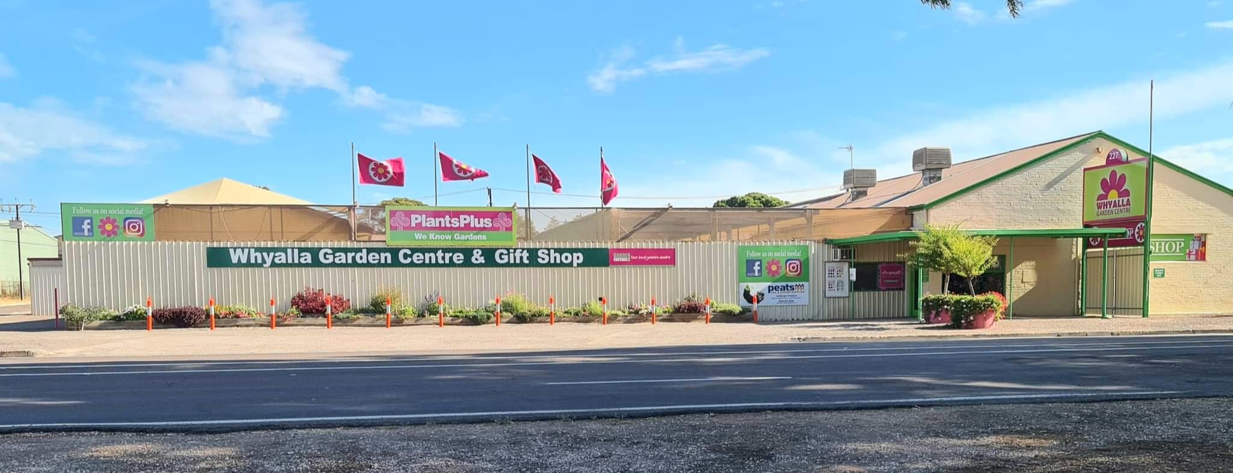
Before too long Len and Vin had taken over another two dry cleaning businesses and turned Arnold Dry Cleaners in George Avenue and Millers Brothers Dry Cleaning in Playford Avenue into receiving shops. At this stage, the astute business men had two dry cleaning factories and five dry cleaning receiving shops, including a gift shop at the ABC shopping centre and a spare building which was leased out to clubs and other organisations.
In continuing their expansion, a large laundry complex adjoining the rear of 227 McBryde Terrace was built, bringing the staffing levels to 26 including two sewing staff, a tailor and seamstress for clothing repairs and alterations. James Dry Cleaners was kept busy with the cleaning of BHP overalls and the cleaning of leather goods for both BHP and the shipyards as well as the laundry from the ships that visited Whyalla's port.
In 1971 Bruce Higgins left high school and joined the team on McBryde Terrace and his sister Leanne joined him in 1976.
Three years later their grandfather, Leonard Tucker, unfortunately died of cancer.
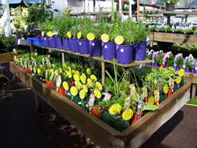 | 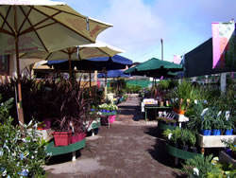
The 1970s was the first time that fashions changed and as people started to dress more casual, wash and wear became the norm. This signalled the start of the decline of the dry-cleaning volume in Whyalla, which had already peaked.
The closure of the shipyards in 1978 and the decline in population saw the five receiving shops and gift shop each gradually fold, leaving just the two factories. Vin then had the foresight in starting up an industrial sewing business especially since there was a new outdoor fabric called woven shade cloth on the market. This was the birth of Whyalla Outdoor Fabrics.
He was also hooked on growing and breeding orchids, so much so that his back yard was covered in them. This interest led to the opening of a garden section on the dry-cleaning side of the site and in 1980 the Whyalla Orchid Nursery began trading.
The outdoor fabrics business grew quickly and was well patronised, while the nursery business slowly but surely began to find it roots.
During that time, there were a number of garden shops in the city including The Garden Shop in town, The Avenue Garden Shop in Essington Lewis Avenue, The Evergreen Nursery at Eight Mile Creek and Gemini Garden Centre in McDouall Stuart Avenue.
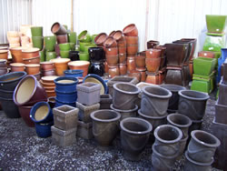 | 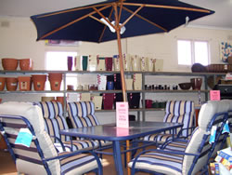
In 1986 the decision was made to close the dry cleaning and laundry factory in McBryde Terrace and sell the Westland factory so that Vin, Bruce and Leanne could develop new business ventures. That ended the dynasty that was James Dry Cleaners. But the story continues.
Back in 1983 the Garden Centre, then known as Whyalla Outdoor Fabric and Garden Centre, joined a South Australian-based Get Growing garden centre group.
This gave them better buying power and the availability of colourful catalogues and a wonderful bi-monthly garden magazine to give to customers.
The Garden Centre expanded quickly and by the early 1990s the old Whyalla Dry Cleaners building next door was turned into a showroom filled with concrete statues and cement pots. This led to the construction of a big 30m by 6m by 4m high shade house.
Around this time Vin decided to go into semi-retirement and by the mid '90s he had retired from working life.
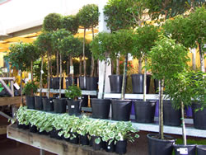
In March 1996, when the Victorian based garden centre group Plants Plus moved into South Australia, many from the Get Growing group chose to join this push for a national group, including Whyalla Garden Centre. This gave the business national buying power.
In 1999 Bruce and Leanne remodelled the shop and the new look showroom took out the Plant Plus Garden Centre of the year South Australia award. In 2001 Whyalla Garden Centre launched their website.
In 2016, the Whyalla Garden Centre became a part of a new group formed in South Australia, Garden Centres of SA. This is a group of independently and locally owned garden centres around the state, both rural and metropolitan, with a shared passion for the gardening industry and for supporting local growers and suppliers.
By being part of a buying group of 15 garden centres strong, we are able to bring our customers competitive prices on all their gardening needs. Three times a year, we meet as a group to network about current trends and challenges in the SA gardening industry, and discuss the catalogues that we would like to bring to our customers, showcasing new releases and special products specifically selected for SA gardeners.
At the Whyalla Garden Centre, we are always evolving. We are always getting fresh and exciting new gift lines in store to cater for everyone, and a range of colourful plants to brighten up the gardens of Whyalla. You never know what you will find here.

